

KRISHIBHAAV – RUBBER PRICE AND BARREL BOOKING SYSTEM

PROJECT REPORT
Submitted in partial fulfillment of the requirements for the award of the degree of Master of Computer Applications of A P J Abdul Kalam Technological University
Submitted by:

JOEL JOPHY (SJC25MCA-2038)

MASTER OF COMPUTER APPLICATIONS
ST. JOSEPH’S COLLEGE OF ENGINEERING AND TECHNOLOGY, PALAI
(AUTONOMOUS)

CHOONDACHERRY P.O, KOTTAYAM
KERALA NOVEMBER 2026

ST. JOSEPH’ S COLLEGE OF ENGINEERING AND TECHNOLOGY, PALAI
(AUTONOMOUS)
(An ISO 9001: 2015 Certified College) CHOONDACHERRY P.O, KOTTAYAM KERALA

CERTIFICATE

This is to certify that the project work entitled 'Krishibhaav' submitted by Joel Jophy (SJC25MCA-2038), student of Third Semester MCA at ST. JOSEPH'S COLLEGE OF ENGINEERING AND TECHNOLOGY, PALAI,in partial fulfillment for the award of Master of Computer Applications, is a bonafide record of the project work carried out by him under our guidance and supervision. This report in any form has not been submitted to any other University or Institute for any purpose.

Prof.Rajeesh A.V Assistant Professor (Project Guide)
Prof.Alex Jose Associate Professor (Project Coordinator)
Dr. Rahul Shajan Associate Professor (HoD-Dept. of CA)

Submitted for the Viva-Voce Examination held on

Examiner 1:

Examiner 2:

DECLARATION

I, Joel Jophy, do hereby declare that the project titled "Krishibhaav" is a record of work carried out under the guidance of Prof. Rajesh A V, Asst. Professor, Department of Computer Applications, SJCET, Palai , as per the requirement of the curriculum of the Master of Computer Applications Programme of A P J Abdul Kalam Technological University, Thiruvananthapuram. Further, I also declare that this report has not been submitted, in full or in part, to any University / Institution for the award of any Degree / Diploma.

Place: Choondacherry JOEL JOPHY
Date: (SJC25MCA-2038)

ACKNOWLEDGEMENT

The success of any project depends largely on the encouragement and guidance of many others. I would like to take this opportunity to express my gratitude to everyone who has supported me in the successful completion of this project.

First and foremost, I thank God Almighty for giving me the wisdom, strength, and guidance to complete this project successfully.

I express my sincere thanks to my parents for their encouragement, love, and support throughout my academic journey and during the development of this project.

I extend my gratitude to Dr. V. P. Devasia, Principal, St. Joseph's College of Engineering and Technology, Palai, for providing the necessary facilities and support.

I express my sincere thanks to Dr. Rahul Shajan, Head of the Department of Computer Applications, SJCET, Palai, for his encouragement and support.

I am deeply grateful to my project guide, Prof. Rajesh A V, Asst. Professor, Department of Computer Applications, SJCET, Palai, for the valuable guidance, suggestions, and support throughout the development of Krishibhaav.

I also thank all the teachers and non-teaching staff of SJCET, Palai, for their support and for the knowledge they have imparted to me.

Finally, I express my appreciation to my friends for their valuable suggestions, help, and encouragement during the completion of this project.

DEPARTMENT OF COMPUTER APPLICATIONS VISION
To emerge as a centre of excellence in the field of computer education with distinct identity and quality in all areas of its activities and develop a new generation of computer professionals with proper leadership, commitment, and moral values.

MISSION
- Provide quality education in Computer Applications and bridge the gap between the academia and industry.
- Promoting innovation research and leadership in areas relevant to the socio-economic progress of the country.
- Develop intellectual curiosity and a commitment to lifelong learning in students, with societal and environmental concerns.

PEO’S (Program Educational Objectives)
- MCA Graduates will be able to progress career productively in software industry, academia, research, entrepreneurship pursuits, government, consulting firms and other IT enabled services.
- MCA Graduates will be able to achieve peer-recognition as an individual or in a team by adopting ethics and professionalism, and communicate effectively to excel well in crisis and inter-disciplinary teams.
- MCA Graduates will be able to continue life-long professional development in computing and in management that contributes in self and societal growth.

PROGRAMME OUTCOME

PO1(Foundation Knowledge): Apply knowledge of mathematics, programming logic, and coding fundamentals for solution architecture and problem-solving.
PO2 (Problem Analysis): Identify, review, formulate, and analyze problems primarily focusing on customer requirements using critical thinking frameworks.
PO3 (Development of Solutions): Design, develop, and investigate problems with an innovative approach for solutions incorporating ESG/SDG goals.
PO4 (Modern Tool Usage): Select, adapt, and apply modern computational tools, such as the development of algorithms, with an understanding of the limitations, including human biases.
PO5 (Individual and Teamwork): Function and communicate effectively as an individual or team leader in diverse and multidisciplinary groups, using methodologies such as agile.
PO6 (Project Management and Finance): Apply the principles of project management, including scheduling and work breakdown structure, and be knowledgeable about finance principles for profitable project management.
PO7 (Ethics): Commit to professional ethics in managing software projects, especially in financial aspects. Learn to use new technologies for cybersecurity and insulate customers from malware.
PO8 (Life-long Learning): Continuously enhance management skills and the ability to learn, keeping up with contemporary technologies and ways of working.

24SJMCA245 MINI PROJECT
Co No | COURSE OUTCOMES | K Level
CO1 | Identify a real-life project which is useful to society  / industry | K2
CO2 | Interact with people to identify the project requirements | K2
CO3 | Apply suitable development methodology for the development of the product / project | K3
CO4 | Analyse and design a software product / project | K3
CO5 | Test the modules at various stages of project development | K3
CO6 | Build and integrate different software modules | K3
CO7 | Document and deploy the product / project | K3

SYNOPSIS

"KRISHIBHAAV" is a Flutter and Firebase based mobile and web application developed to simplify rubber price communication and barrel booking between rubber farmers and their buying agents in Kerala. Farmers usually learn the day's rubber rate through phone calls and forwarded WhatsApp messages, and barrels are requested and returned with no shared record. Krishibhaav addresses these problems by providing one secure platform where a farmer can see the price that applies to them, compare it with the Rubber Board and Rubber Board rate, and book and track barrels, while the agent manages prices and stock in one place.
The system is designed with two user roles, Agent and Farmer. Users register and sign in with a mobile number and a password. Each agent receives a unique agent code, and a farmer links to an agent by sending a request with that code, which the agent accepts or rejects. The agent sets a global price, can set a custom price for an individual farmer, and chooses for each farmer whether the Rubber Board and Rubber Board rate are shown. Open-market RSS4 and RSS5 rates are read from a pasted WhatsApp rate message, and the Rubber Board rate is collected automatically by a Python scraper that runs on GitHub Actions. The farmer sees one effective price, which is the custom price if one is set and the agent's global price otherwise, together with price history charts. Farmers request barrels, and agents approve, dispatch, and record returns or cancellations, with barrel stock updated at each step. The application uses Flutter for Android and the web, Firebase Authentication, Cloud Firestore and Firebase Hosting, and runs on free-tier services.

TABLE OF CONTENTS

- Introduction 1
  - About the project 2
  - Objective of the project 2
  - Scope of the project 3
- Initial investigation and Feasibility study 4
  - Initial Investigation 5
  - Feasibility study 7
    - Economic Feasibility 7
    - Technical feasibility 7
    - Behavioral feasibility 7
    - Operational feasibility 8
- System Analysis 9
  - System Analysis 10
  - Existing system 10
  - Proposed System 11
  - Software Requirement Specification 11
- Modules 16
  - Modules 17
    - User Management Module 17
    - Price Management Module 17
    - Barrel and Stock Module 17
    - Market Data and Price History 17
    - Notification Module ………………...17
- Flow Diagrams 18
  - Use Case Diagram 19
  - Class Diagram 20
- System Design 23
  - System Design 24
  - InputDesign. 24
  - OutputDesign. 25
  - TableDesign. 25
- Tools and Platform 29
  - Front end 30
  - Back end 30
  - Framework 30
  - Platform 31
  - Database 31
- Testing 32
  - Unit Testing 33
  - Integration Testing 33
  - System Testing 33
    - Acceptance Testing 33
    - Validation Testing 33
    - Black Box Testing 34
    - White Box Testing 34
  - Sample Test Cases 34
- System Implementation 36
  - Implementation 37
  - Problem Statement 37
  - Problem Definition 37
- Conclusion 39
- Appendices 41
- Sample Screens 42
- Sample Code 50
- Hardware and Software Requirements 53
- Bibliography 54

INTRODUCTION

1.1 About the Project
Krishibhaav is a mobile and web application that gives rubber farmers in Kerala a single place to see the price they will actually be paid and to book rubber barrels from their buying agent. Rubber is sold through local agents, and the rate a farmer receives usually differs from the Rubber Rubber Board rate and the open-market rate. Farmers normally learn these rates through phone calls and forwarded WhatsApp messages, which are slow and easy to misread. Barrel booking is arranged the same way, by phone, with no record of what was asked for or approved.
Krishibhaav connects a farmer to one agent through a short agent code. The agent sets a global price, can give an individual farmer a custom price, can choose whether the farmer also sees the Rubber Board and Rubber Board rate, and manages barrel stock and bookings. The farmer sees one effective price: the custom price if the agent has set one, otherwise the agent's global price. Price history is shown as charts so that a farmer can follow the trend.
The app is built with Flutter, so one code base serves Android and the web. Firebase Authentication handles sign-in, Cloud Firestore (asia-south1) stores the data, and Firebase Hosting serves the web version at krishibhaav.web.app. A separate Python scraper, run on a schedule through GitHub Actions, collects Rubber Board rate. The Android build is published as a GitHub release (v1.0.0, krishibhaav.apk).
1.2 Objective of the Project
The main objective is to replace phone calls and forwarded messages with one reliable, role-based system for rubber prices and barrel booking. The specific objectives are:
- To let each farmer see the price payable by their own agent, including any individual rate.
- To let agents publish and update prices quickly, and to optionally show Rubber Board and Rubber Board rate.
- To maintain price history and show it as trend charts.
- To let farmers request barrels and let agents approve, dispatch and track them, with barrel stock updated automatically.
- To keep each farmer's data visible only to the agent they are linked to and to that farmer.
- To provide a free-to-run solution on the Firebase Spark plan and free tools.

1.3 Scope of the Project
Krishibhaav covers two user roles, Agent and Farmer.
Within scope:
- Registration and login with mobile number and password.
- Linking a farmer to an agent through an agent code and a request that the agent accepts or rejects.
- Agent price management: global price, custom farmer prices, and visibility settings for the Rubber Board and Rubber Board rate.
- Open-market rate entry from a pasted WhatsApp message.
- Automatic collection of the Rubber Board rate by a scheduled scraper.
- Price history charts for farmers and agents.
- Barrel stock management.
- Barrel booking with the statuses requested, approved, dispatched, returned and cancelled.
- An Android and web client built from one code base.
Outside the present scope:
- Online payment.
- Delivery tracking.
- Support for grades beyond RSS4 and RSS5.
- Multi-language support.
Some of these are listed as future enhancements in Chapter 10.

INITIAL INVESTIGATION AND FEASIBILITY STUDY

2.1 Initial Investigation

The initial investigation examined how rubber prices and barrels are currently handled between farmers and their buying agents. It was carried out through interviews informal discussions and observation with a group of farmers and 2 agents in Akalakunnam village during June July. The aim was to understand how price information and barrels move between a farmer and the agent who buys from them. Five main findings emerged, and each led directly to a requirement listed in Section 3.4.
- Price communication. A farmer learns the day’s rate when the agent phones or when a message is forwarded on WhatsApp. These messages are informal, are passed from group to group, and carry no date, grade or sender, so a farmer who receives two figures cannot tell which one is current or applies to them. Krishibhaav shows each farmer a single effective price: the agent’s custom price for that farmer if one is set, and otherwise the agent’s default price for all linked farmers.
- Comparison of rates. Three figures are in use at once: the Rubber Board benchmark rate, the open-market rate, and the agent’s own rate. The differences are legitimate, but farmers have no simple way to see them side by side and judge whether their rate is fair. In Krishibhaav, the Board rate is collected automatically by a scheduled scraper, the agent enters the open-market rate, and the agent decides whether each farmer may see the Board and open-market figures alongside their own price.
- Price history. Past rates are not recorded anywhere a farmer can consult them, so judging whether prices are rising or falling depends on memory. Krishibhaav stores daily price records and shows the latest 30 days as a trend, with 7-day and 30-day highs and lows.
- Barrel requests. Barrels are requested by phone, and nothing is written down about the quantity, the agent’s approval, the handover, or whether barrels came back empty or filled. This causes disagreements over quantities, delays, and barrels staying with one farmer for long periods. Krishibhaav replaces the call with a booking that records the farmer, agent, quantity and date. It moves through the stages requested, approved, dispatched, and then returned, returned empty, returned filled or cancelled. Each stage is timestamped and the farmer can view the booking history.
- Stock overview for agents. An agent has no single place to compare the barrels they own, the barrels with farmers and the requests awaiting approval, so decisions are made from memory or a notebook. Krishibhaav keeps a stock record per agent with total and available barrels, adjusted when a booking is approved, cancelled or returned.

Summary. The main difficulty is the absence of one trusted, shared and recorded source of information, not a shortage of data. Prices exist but are scattered, and barrels move but are not tracked. This shaped the requirements in Section 3.4, which group into price visibility, price history and barrel tracking.

2.2 Feasibility Study

A feasibility study was carried out to confirm that Krishibhaav could be built, deployed and used with the resources available. Four aspects were examined: economic, technical, behavioral and operational.

2.2.1 Economic Feasibility

Economic feasibility checks whether the benefits of the system justify its cost. Krishibhaav needs no paid software and no hardware beyond the developer’s own computer.

Development tools: Flutter, Dart and Visual Studio Code are free and open source.

Back end: Firebase Authentication, Cloud Firestore and Firebase Hosting run on the free Spark plan.

Price collection: the Python scraper runs on the free allowance of GitHub Actions, so Rubber Board rates are collected daily without a server.

Users: a farmer or agent needs only a smartphone or a web browser with internet access, which they already have.

The main cost is the developer’s time. If usage later grows past the free limits, the Firebase Blaze plan charges only for what is used, so costs would rise gradually with the number of users. The system is therefore economically feasible.

2.2.2 Technical Feasibility

Technical feasibility checks whether the required technology exists and can be handled with the available skills.

One code base: Flutter produces both the Android app and the web app from the same Dart code.

No server to maintain: Firebase supplies authentication, a real-time database and hosting.

Data protection: Firestore security rules allow each user to read and write only the data their role permits.

Automation: the scraper is a small Python program that writes the Rubber Board rate to Firestore on a schedule.

All of these tools are mature, widely used and well documented, and the developer already had the skills to use them. The system is therefore technically feasible.

2.2.3 Behavioral Feasibility

Behavioral feasibility checks whether the intended users will accept and use the system.

Farmers and agents already use smartphones and WhatsApp every day, so a mobile app is a familiar way for them to receive information. The interface is designed to need little training: the current price is shown prominently, forms are short, and typing is kept to a minimum. Login uses a mobile number and password, which users already understand from other apps. The agent also stays in control, because a farmer is linked only after the agent accepts the request.

Krishibhaav does not change how agents and farmers do business. It makes the same information faster, clearer and recorded. Users are therefore expected to accept it.

2.2.4 Operational Feasibility

Operational feasibility checks whether the system will work smoothly in the daily routine of its users.

The system follows the existing working pattern. The agent still decides the prices and manages the barrels, and the farmer still books barrels from the agent. An agent can update a price in a few steps, and linked farmers see the change as soon as it is saved. Rubber Board rates are collected automatically each day, which removes manual entry. Because data is stored in the cloud and the app is served from Firebase Hosting, there is no local installation or maintenance for the user. The system is therefore operationally feasible.

Conclusion of Feasibility Study

The study shows that Krishibhaav is feasible on all four counts. It costs almost nothing to run, uses proven technology, suits the habits of its users and fits their daily work. The project was therefore taken forward to the analysis and design stages.

SYSTEM ANALYSIS

3.1 System Analysis
System analysis is the study of how a problem currently exists and what must be built to solve it. It breaks the situation into its parts, such as the people involved, the information they use and the way that information moves, and then puts those parts together again as a better whole. The result of this phase is a specification of what the software must do, which guides the design and development that follow.
For Krishibhaav, the analysis looked at four things: how prices are communicated to farmers, how barrels are requested and returned, who should be able to see which data, and what an agent needs in order to manage many farmers. The problems of the current way of working were identified, and the features needed to solve them were recorded as the requirements in Section 3.4.
3.2 Existing System
The existing way of working between rubber agents and farmers is informal and scattered. An agent normally tells the day’s rate by phone call or WhatsApp message, often to one farmer at a time or in a forwarded group message. The Rubber Board rate and the open-market rate are checked separately, from the Board’s notifications and from market messages, and farmers have no simple way to compare them with the rate the agent offers. A price agreed with one particular farmer is not written down anywhere. Barrels are requested by phone and tracked in the agent’s notebook or memory, so the quantity requested, approved, handed over and returned is hard to verify. Past prices are not kept, so a farmer cannot look at the trend. Overall, the current method lacks a single digital platform that gives both farmers and agents the same, up-to-date information, which causes confusion about prices, disputes about barrels and a lot of repeated effort.
Limitations of the existing system:
- Prices are scattered across calls and messages and are easy to miss or misread.
- A farmer's individual rate cannot be shown clearly beside the general rate.
- No price history is available.
- Barrel requests and returns are not recorded, so stock and dues are hard to verify.
- Agents spend time repeating the same price to many farmers.
- There is no control over who sees which information.

3.3 Proposed System
The proposed system is an integrated mobile and web application that replaces these scattered steps with one platform. The system supports two user roles, Agent and Farmer, which keeps the workflow clear.

For agents, the application lets them enter a global price once and set a different price for any linked farmer.
The agent can choose, for each farmer, whether the Rubber Rubber Board rate and the open-market rate are shown. The agent can paste a WhatsApp rate message, from which the RSS4 and RSS5 Rubber Board rate are read automatically, and the Rubber Rubber Board rate is collected by an automatic scraper. The agent also maintains barrel stock, and approves, dispatches, and records the return or cancellation of barrel bookings, with stock updated by each action.
For farmers, the application shows the effective price as soon as it is opened, which is the individual price if the agent has set one and the agent's global price otherwise. The Rubber Board rate and the open-market rate are shown if the agent allows them. Price history is shown as charts, and the farmer can request barrels and follow the status of each request.
Firestore security rules keep each farmer's data private to that farmer and the linked agent. The system is built on Firebase and runs on its free tier.
Advantages of the proposed system:
- A single, current price for each farmer.
- Less time spent on repeated phone calls.
- Price history and trend charts.
- A written record of barrel requests and their status.
- Role-based access and private data.
- Runs on the free tier of Firebase.
3.4 Software Requirement Specification (SRS)
This Software Requirements Specification (SRS) describes the Krishibhaav rubber price and barrel booking application. It outlines the functional and non-functional requirements, the roles of the different users, the interfaces and the overall behaviour of the application. The document serves as a foundational reference for the design, development and deployment of a secure, efficient and user-friendly platform for rubber price information and barrel management. It defines the interactions between agents and farmers and aims to guide developers and stakeholders in building a reliable solution.
A. Scope
The scope of the project includes the development of a mobile and web application with the following features:
- Registration and login with mobile number and password.
- Linking of a farmer to an agent using the agent code.
- Agent price management (global price and custom price for each farmer).
- Reading of RSS4 and RSS5 Rubber Board rate from a pasted WhatsApp message, and automatic collection of the Rubber Rubber Board rate.
- Price history charts for farmers.
- Barrel stock and booking management.
- Role-based access for Agent and Farmer.
B. Overall Description
Product Perspective
Krishibhaav is a standalone application developed to simplify rubber price communication and barrel handling. It is built with Flutter (Dart) for Android and the web. The back end uses Firebase Authentication, Cloud Firestore and Firebase Hosting, and a Python scraper running on GitHub Actions supplies the Rubber Rubber Board rate.
Product Functions
- Agent functions: price management for all farmers and for individual farmers, setting what each farmer can see, accepting or rejecting link requests, entering Rubber Board rate from a pasted message, barrel stock management, and approving, dispatching and closing barrel bookings.
- Farmer functions: sending a link request to an agent, viewing the effective price, Board and Rubber Board rate (when allowed) and price history, requesting barrels and tracking their status.
- User Characteristics
- Agent: a rubber buyer who handles prices and barrels for several farmers and uses a smartphone for calls and WhatsApp.
- Farmer: a rubber grower with basic digital skills who can open an app, read a price and fill in a short form.
Constraints
- The application needs an internet connection to show current data.
- Data security and privacy must be maintained for all users.
- The system is built on the Firebase Spark plan, which has daily usage limits.
- Assumptions and Dependencies
- The agent keeps the prices up to date, since farmers depend on them.
- The Rubber Rubber Board rate depends on the scraper and the source it reads.
- Future enhancements may include push notifications, a one-time password at sign-up, more settlement options and an iOS version.
C. Functional Requirements
User Registration and Authentication
- Users can register with name, mobile number, password, location and role (Agent or Farmer).
- Users can log in and log out securely and are taken to the home screen for their role.
- Linking
- Each agent gets a unique agent code.
- A farmer can send a link request to an agent using that code, and the agent can accept or reject it. A linked farmer's data is unlocked when the request is accepted, and an unlinked farmer sees only an empty state.
- Price Management
- An agent can set a global price and a custom price for an individual farmer.
- An agent can choose, for each farmer, whether the Rubber Board rate and the open-market rate are shown.
- An agent can paste a WhatsApp rate message and have the RSS4 and RSS5 Rubber Board rate read from it.
- A farmer can view the effective price, and view price history as a chart.
- Barrel Management
- An agent can maintain barrel stock.
- A farmer can request barrels. An agent can approve, dispatch, mark returned (filled or empty) or cancel a booking, with stock adjusted accordingly.
Role-Based Access Control
- Agent: manages prices, linked farmers, stock and bookings.
- Farmer: views own prices and history, and requests and tracks own bookings.
- Notifications and Updates
- Prices and booking status are updated on screen in real time. The system is also prepared for device notifications through Firebase Cloud Messaging.
D. Non-Functional Requirements
Performance
- Prices and bookings should update on the screen in near real time through Firestore.
- Screens should respond quickly under normal use.
- Usability
- The interface should be simple, with the main price shown first, so that users with basic digital skills can use it.
- Security

- User data is stored in Firebase, and passwords are handled by Firebase Authentication.
- Firestore security rules restrict access by role and by the link between farmer and agent.
- Scalability
- The system is designed so that more users, grades and features can be added without a major redesign.
- Portability
- One Flutter code base serves both Android and the web.
Maintainability
Logic is separated into models, services and providers, with unit tests for the core booking and parsing rules.

E. User Interface Requirements
- The application should have a responsive design suitable for phones and for the web.
- Clear and consistent navigation should be maintained across all screens for each role.
F. System Architecture
System Design
The system follows a client-cloud model. The client is the Flutter application on Android or in a web browser, and it communicates directly with Firebase services. The database layer is Cloud Firestore.
- Front end: Flutter (Dart).
- Back end: Firebase Authentication, Cloud Firestore, Firebase Hosting; Python scraper on GitHub Actions.
- Database: Cloud Firestore.
Data Flow
- User interaction: the user acts on the Flutter application.
- Request handling: the application reads and writes Firestore, which checks the security rules.
- Response generation: Firestore sends the data and live updates back to the application for display.

G. Hardware and Software Requirements
Client: An Android phone, or any modern web browser, with an internet connection.
Development: AMD Ryzen AI 7 350 processor, 24 GB RAM and 954 GB storage, Windows 11 Home Single Language, Flutter, Dart Visual Studio Code, Firebase, Python, Git and GitHub
H. Conclusion
This SRS outlines the key requirements for Krishibhaav. The successful implementation of these requirements ensures that the system meets the needs of agents and farmers, gives clear and secure access to prices, and supports organised barrel management.

MODULES

4.1 Modules
Krishibhaav is divided into five modules.
4.1.1 User Management Module
Handles registration, login, role selection (Agent or Farmer) and the link between a farmer and an agent. Each agent has a unique agent code. A farmer sends a link request with that code, and the agent accepts or rejects it. Until a request is accepted, the farmer sees only an empty state. Access to all other data depends on this link.
4.1.2 Price Management Module
Lets the agent set the global price, set a custom price for a single farmer, and choose whether farmers can see the Rubber Board and Rubber Board rate. The farmer's screen shows the effective price: the custom price if one exists, otherwise the global price. Open-market rate rates can be entered by pasting a WhatsApp message, from which the RSS4 and RSS5 rates are read.
4.1.3 Barrel and Stock Module
Lets the agent maintain barrel stock and manage bookings. A farmer requests a quantity. The agent approves (stock reduced), dispatches, and records the return as returned, returned empty or returned filled (stock added back). An approved booking that is cancelled returns its barrels to stock. Approval is refused if the requested quantity is more than the available stock.
4.1.4 Market Data and Price History Module
Collects Rubber Board rate using the Python scraper on GitHub Actions and stores them in Firestore. Stores price history for the agent's price, farmer prices and market rates, and shows them as trend charts using fl_chart.
4.1.5 Notification Module
Prepared for sending notifications to users through Firebase Cloud Messaging (FCM), such as price updates, link responses and booking changes. Device tokens are stored with the user profile and the dispatch logic is in place.

FLOW DIAGRAMS

Use Case Diagram
A Use Case Diagram is a UML diagram that shows how users (actors) interact with a system and its functions (use cases). It provides a high-level view of system requirements and scope.
    - Represents actors (users or external systems) and the use cases they interact with.
    - Shows relationships between users and system functionalities, making requirements easier to understand.
Use Case Diagram Symbols
    - Actor: Represents a user or an external entity interacting with the system.

    - Use Case: Represented by an oval. It describes a function performed by the system.
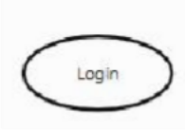
    - System Boundary: Represented by a rectangle enclosing the use cases.
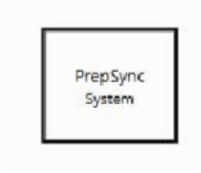

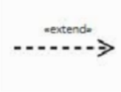
    - Include Relationship: Represented by a dashed arrow labelled «include». It indicates that one use case always includes the behaviour of another use case.

    - Extend Relationship: Represented by a dashed arrow labelled «extend». It indicates optional or conditional behaviour added to another use case.
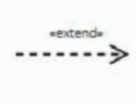

Use Case Diagram
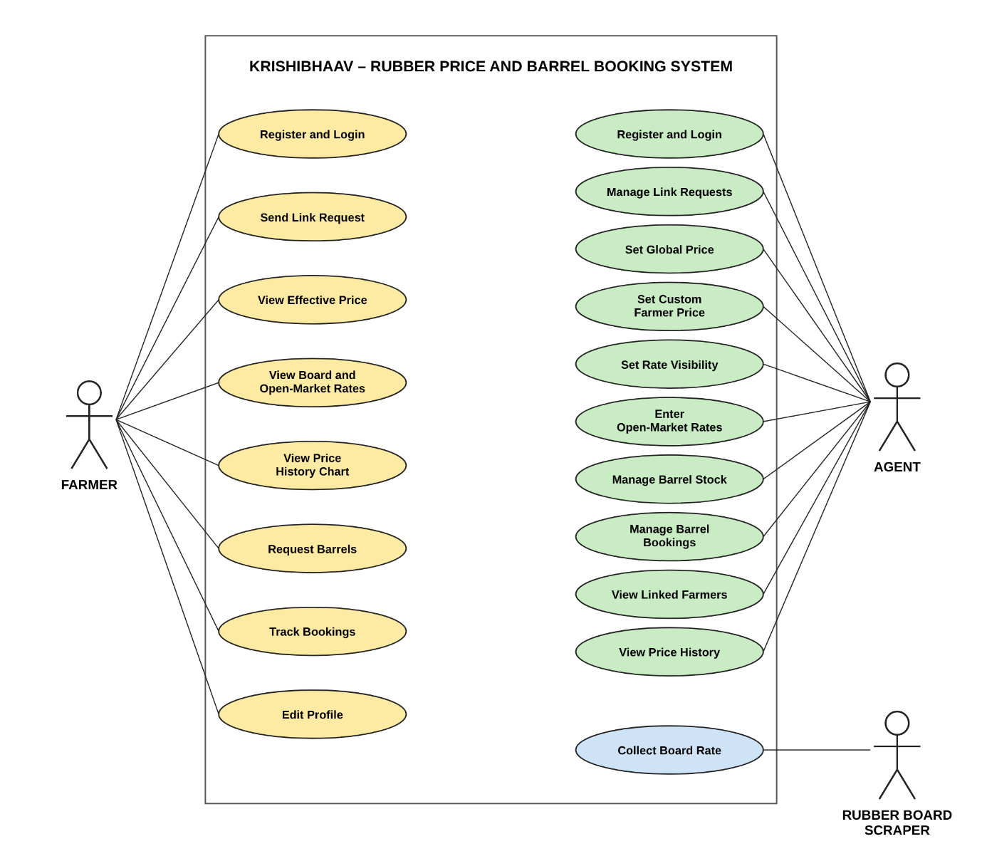

Class Diagram

A UML class diagram shows the structure of a system by displaying its classes, their attributes, methods, and the relationships between them. It helps the team understand how the system is organized and how components interact.
    - Represents classes, attributes, methods, and relationships within a system.
    - Helps developers understand, communicate, and document the software structure more effectively.

Class Diagram Symbols

    - Attribute: Represents the data or properties of a class.
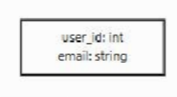

    - Class:Represented by a rectangle divided into three compartments: class name, attributes, and methods.
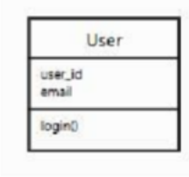

    - Method / Operation: Represents the behaviour or functions performed by a class.
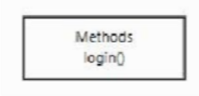
    - Association: Represented by a solid line connecting two classes to indicate the relationship between them.
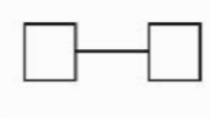

Class Diagram
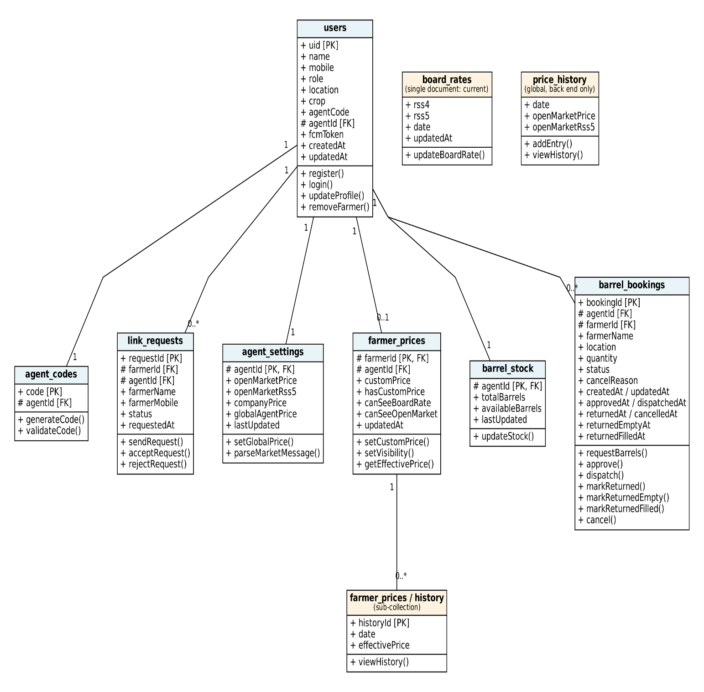

SYSTEM DESIGN

6.1 System Design
System design is the process of defining the architecture, components, modules, interfaces and data of a system so that it satisfies the specified requirements. It answers the question "how will it be done?", whereas system analysis answers "what is needed?". The design phase translates the requirements gathered during analysis into a form that can be built and put to use. Krishibhaav is designed as a Flutter client that works with Firebase services: Firebase Authentication for sign-in, Cloud Firestore for data, Firebase Hosting for the web version, and a separate Python scraper that supplies Rubber Board rate. The system is developed as separate modules, namely user management, price management, barrel and stock, market data and price history, and notification, which are combined to work as a single application. Three design areas are discussed in the sections below. In input design, the input screens and the data they accept are decided. In output design, the output screens and the information shown to the user are decided. In database design, the collections and fields needed to store the data are decided.
6.2 Input Design
Input design converts user-oriented inputs into a computer-based format and needs careful attention. Inaccurate input data is the most common cause of errors in data processing, so the input screens of Krishibhaav are kept short and are designed logically. The main input screens are registration, login, the farmer's link request using an agent code, the agent's price entry screens (global price and custom farmer price), the screen where the agent pastes a WhatsApp rate message, the barrel stock screen and the barrel booking request form.
While data is entered in these forms, validation checks are made and the system shows a message when the data is incorrect. For example, registration is rejected if the name is empty, the mobile number has fewer than 10 digits or the password has fewer than 6 characters, and a pasted message that contains no rates produces an error message. Navigation is provided through a bottom navigation bar and clear screen titles for each role, so that an agent or a farmer reaches the right screen with few taps.
The objective of input design is to create an input layout that is easy to follow and that prevents user errors. It covers all phases of input, from the creation of the initial data to its actual entry into the system for processing. Input design is the link that ties the system to its users. The interface design defines how the software communicates within itself, with other systems and with the people who use it. User friendliness, a consistent format, and dialogues that give the right message and help at the right time were also considered in developing the project.

6.3 Output Design
Outputs are the most important and useful information that the system gives to its users. Well-designed outputs improve the relationship between the system and its users and help them make decisions, such as when to sell or which price is better. The outputs of Krishibhaav include the effective price shown to the farmer, the Rubber Board and Rubber Board rate (shown only when the agent allows), price history charts, the list of linked farmers and pending link requests for the agent, barrel stock figures, and booking lists with their status. The screens used in the system are shown in the appendix.
The outputs vary in content, frequency, timing and format. Prices and bookings are updated on screen as soon as the data changes in Firestore. The users of each output, its purpose and the sequence of details shown were all considered. The outputs justify the existence of a system, and if they are inadequate in any way, the system itself is inadequate. The basic requirement is that outputs be accurate, timely and appropriate in content, medium and layout for their intended purpose. The outputs are therefore designed so that the objectives of the system are met in the best possible manner.
6.4 Table Design
The efficiency of an application that uses Cloud Firestore depends mainly on how the collections and their fields are designed, and on how related data is connected through the fields they hold. Firestore is a NoSQL document database. Data is organised into collections of documents, and each document holds a set of fields. Unlike a relational table, a collection does not force every document to have the same structure, and related data is connected by storing the identifier of one document in another, for example a farmer's agent ID. Each document is identified by a unique document ID, which acts like a primary key. The primary objectives of the database design are fast response to queries, more information at low cost, control of redundancy, clarity and ease of use, accuracy and integrity of the data, and fast recovery and availability. In this project, access to the data is also controlled with Firestore security rules, so that each user can read and write only the data they are entitled to.

1. users – details of every user. Document ID = uid.
Field | Type | Description
uid (PK) | VARCHAR | Firebase Auth user ID
name | VARCHAR | Full name
mobile | VARCHAR | Mobile number, also the login ID
role | VARCHAR | farmer / agent
location | VARCHAR | Place
crop | VARCHAR | Crop (Rubber)
agentCode | VARCHAR(6) | Agents only; code shared with farmers
agentId (FK) | VARCHAR | Linked agent, set after approval
fcmToken | VARCHAR | Device token for notifications
updatedAt | TIMESTAMP | Last profile update

2. agent_codes – Document ID = code.
Field | Type | Description
code (PK) | VARCHAR(6) | Agent code
agentId (FK) | VARCHAR | Agent who owns the code

3. link_requests – Document ID = farmerId_agentId.
Field | Type | Description
requestId (PK) | VARCHAR | farmerId + "_" + agentId
farmerId (FK) | VARCHAR | Requesting farmer
farmerName, farmerMobile | VARCHAR | Farmer details
agentId (FK) | VARCHAR | Target agent
status | VARCHAR | pending / accepted / rejected
requestedAt | TIMESTAMP | Request time

4. agent_settings – Document ID = agentId.
Field | Type | Description
agentId (PK, FK) | VARCHAR | Agent
openMarketPrice | DOUBLE | Open-market RSS4 price
openMarketRss5 | DOUBLE | Open-market RSS5 price
companyPrice | DOUBLE | Company price
globalAgentPrice | DOUBLE | Agent's default price
lastUpdated | TIMESTAMP | Last update

5. farmer_prices – Document ID = farmerId. It has a history subcollection of daily effective prices (date, effectivePrice)
Field | Type | Description
farmerId (PK, FK) | VARCHAR | Farmer
agentId (FK) | VARCHAR | Agent
customPrice | DOUBLE | Price set for this farmer
hasCustomPrice | BOOLEAN | Whether it applies
canSeeBoardRate | BOOLEAN | Rubber Board rate visible
canSeeOpenMarket | BOOLEAN | Open-market rate visible
updatedAt | TIMESTAMP | Last update

6. board_rates – a single document named current.
Field | Type | Description
rss4 | DOUBLE | Rubber Board RSS4 rate
rss5 | DOUBLE | Rubber Board RSS5 rate
date | VARCHAR | Rate date
updatedAt | TIMESTAMP | Collection time

7. price_history – daily open-market history
Field | Type | Description
date | VARCHAR | Day of the price
openMarketPrice | DOUBLE | RSS4 open-market price
openMarketRss5 | DOUBLE | RSS5 open-market price

8. barrel_stock – Document ID = agentId.
Field | Type | Description
agentId (PK, FK) | VARCHAR | Agent
totalBarrels | INT | Barrels owned
availableBarrels | INT | Barrels free
lastUpdated | TIMESTAMP | Last update

9. barrel_bookings – Document ID = bookingId.
Field | Type | Description
bookingId (PK) | VARCHAR | Booking ID
agentId (FK), farmerId (FK) | VARCHAR | The two parties
farmerName, location | VARCHAR | Display details
quantity | INT | Barrels requested
status | VARCHAR | requested, approved, dispatched, returned, returned_empty, returned_filled, cancelled
cancelReason | VARCHAR | Reason if cancelled
createdAt, updatedAt, requestedAt | TIMESTAMP | Record times
approvedAt, dispatchedAt, returnedAt, cancelledAt, returnedEmptyAt, returnedFilledAt | TIMESTAMP | Time of each stage

TOOLS AND PLATFORM

7.1 Front End: Flutter (Dart)
The front end of an application is what users directly interact with. Krishibhaav's front end is built with Flutter, Google's open-source toolkit for building mobile and web applications from a single codebase, using the Dart programming language. Dart is easy to read, is strongly typed and compiles to fast native code, which keeps the screens smooth on ordinary phones. Every screen in Flutter is made of widgets, which define the layout, text, buttons, forms and charts that the user sees. Several packages support the interface. Provider and RxDart manage the state of the app and the live data streams, so that a change in the database appears on the screen without a manual reload. go_router handles navigation between screens and sends each user to the correct home screen for their role. fl_chart draws the price history charts, and shared_preferences keeps a small offline copy of the latest prices on the device. Together these tools give farmers and agents a responsive, consistent and easy-to-use interface on both Android and the web.
7.2 Back End: Firebase
The back end of Krishibhaav is provided by Firebase, a Google platform that supplies ready-made server-side services, so no separate server needs to be built or maintained. Firebase Authentication manages registration and sign-in, using the mobile number and a password. Cloud Firestore stores all application data. Firebase Cloud Messaging provides the means of sending messages to user devices, and Firebase Hosting serves the web version of the app at krishibhaav.web.app. In addition, a Python program, KrishibhaavScraper, collects the Rubber Board and Rubber Board rate and stores them in the database. Python is readable and has strong libraries for reading web data, which makes it a good choice for this task. Using Firebase lets the project run on the free Spark plan while still offering secure, scalable and always-available services.
7.3 Framework: Flutter
Flutter is a high-level cross-platform framework for building user interfaces. It provides built-in widgets, a rendering engine, navigation tools and support for testing, so that common work does not need to be written from scratch. Its widget-based design gives the same look and behaviour on Android and the web, and it supports both light and dark themes. A single codebase serves both platforms, which reduces development time and keeps the two versions consistent. The code is organised into models, services and providers, which separates the data, the logic and the display. This makes the project easier to maintain and to test.

7.4 Platform: Visual Studio Code
Visual Studio Code (VS Code) is a lightweight and powerful code editor used as the primary platform for developing and managing the project. With the Dart and Flutter extensions, it supports code completion, debugging, hot reload, syntax highlighting and integrated Git. Hot reload lets changes appear in the running app within a moment, which speeds up building and checking screens. GitHub stores the source code and its version history, and GitHub Actions runs the scraper on a schedule and publishes the Android release. Together they give one convenient workspace for coding, testing and releasing the application.
7.5 Database: Cloud Firestore
Cloud Firestore is a flexible, scalable NoSQL cloud database from Firebase. The data for Krishibhaav is stored in the asia-south1 (Mumbai) region, which is close to its users in Kerala. Firestore stores data as documents inside collections, and a document can hold fields of different types, such as text, numbers, dates and references to other documents. It sends live updates to the app, so when an agent changes a price or a barrel booking changes status, the farmer's screen refreshes automatically. Firestore security rules control who can read and write each document, so that a farmer sees only their own data and the data shared by the linked agent. It requires no server setup and has a generous free tier, which makes it well suited to a project of this size, while still being able to grow to many more users.

TESTING
8.1 Unit Testing
Unit testing focuses verification effort on the smallest unit of software design in each module. It is also known as module testing. In Krishibhaav, each module is tested separately to check that it gives the expected output, and the tests are written in the programming language of the project itself (Dart) using the Flutter test framework. The unit tests cover the barrel booking decision rules for every status, the parser that reads RSS4 and RSS5 rates from a pasted WhatsApp message, the price statistics, the user model and the registration validation. Different modules are tested against the specifications produced during their design. Because a unit is small, the programmer who developed it can test it in great detail. Errors found at this stage are corrected and the unit is tested again, so that it fits properly into the project. The 60 unit and widget tests in the test folder were run with the flutter test command, and all of them passed.
8.2 Integration Testing
Data can be lost across an interface, one module can have an adverse effect on another, and modules that work alone may not give the desired result when combined. Integration testing is the systematic testing carried out to uncover errors in the interfaces between modules. After the program was split into units, the units were tested together to find defects between modules and functions. In Krishibhaav, the link request flow between a farmer and an agent, the router redirects that send each user to the correct screen for their role, and the farmer home screen were tested together using simulated data. The system ran correctly with this data, which gives confidence in the overall performance of the connected modules.
8.3 System Testing
System testing focuses on testing the system as a whole. It is the first level at which the application is tested as one complete system, and it is a crucial step in the quality management process. The application is tested in an environment that closely resembles the one in which it will finally be used. The prerequisites for system testing are:
- All the components should have been successfully unit tested.
- All the components should have been successfully integrated.
- Testing should be done in an environment that closely resembles the real environment.

8.3.1 Acceptance Testing
Acceptance testing checks whether the system meets the requirements defined in the analysis stage, as judged by its intended users.
8.3.2 Validation Testing
Data validation is the process of checking the accuracy of the data entered. A set of rules is applied to each input field to specify the type and range of data that is allowed, and an error message is displayed when incorrect values are entered.
In Krishibhaav, validation was tested for the registration and login forms and for the price input. Incorrect values such as an empty name, a mobile number that does not have 10 digits and a password shorter than 6 characters are rejected with a message, and a pasted message that contains no rates produces an error. Validation is considered successful when the software functions in a manner that the user can reasonably accept.
8.3.3 Black Box Testing
Knowing the specified functions that a product has been designed to perform, tests can be carried out to show that each function is fully operational, while searching for errors in each function. Black box testing focuses on the functional requirements of the software and does not look at the code. In Krishibhaav, each function, such as registration, linking to an agent, approving a booking and viewing the effective price, was tested against its requirement by checking the output for a given input. The test cases and their results are given in Section 8.4.
8.3.4 White Box Testing
Knowing the internal working of a product, tests can be carried out to ensure that "all the gears mesh", that is, the internal operation performs according to the specification and all internal components have been adequately exercised. In Krishibhaav, the internal logic of the booking decision functions was tested for every status (requested, approved, dispatched, returned, returned empty, returned filled and cancelled), including the cases that must be refused, such as approving more barrels than are in stock
.8.4 Sample Test Cases
TC | Test steps | Expected result | Actual result | Status
1 | Approve a requested booking with enough free barrels | Status approved, free barrels reduced by quantity | Status changed to approved; free barrels reduced by quantity | Pass
2 | Approve with fewer free barrels than requested | Rejected as overbooking | Rejected with an overbooking error | Pass
3 | Approve an already approved booking | No change | No change made | Pass
4 | Dispatch an approved booking | Status dispatched | Status changed to dispatched | Pass
5 | Return a dispatched booking | Status returned, barrels added back | Status returned; barrels added back | Pass
6 | Cancel an approved booking | Status cancelled, barrels added back | Status cancelled; barrels added back | Pass
7 | Cancel a dispatched booking | Not allowed | No change made | Pass
8 | Paste a full WhatsApp message | RSS4 and RSS5 both read | Both rates read | Pass
9 | Paste a message missing the RSS4 line | RSS4 empty, RSS5 read | RSS4 empty; RSS5 read | Pass
10 | Paste unrelated text | Error message shown | Error message shown | Pass
11 | Register with empty name | Rejected | Rejected | Pass
12 | Register with a mobile number of fewer than 10 digits | Rejected | Rejected | Pass
13 | Register with a 5-character password | Rejected | Rejected | Pass
14 | Agent finishes registration | Goes to agent home | Routed to agent home | Pass
15 | New farmer without an agent logs in | Goes to the link request screen | Routed to the link request screen | Pass
16 | Linked farmer logs in | Goes to farmer home | Routed to farmer home | Pass
17 | Unlinked farmer opens the app | Sees only the empty state, no agent data | Empty state shown; no agent data | Pass
18 | Agent accepts a request | Farmer's data unlocks | Farmer's data unlocked | Pass

SYSTEM IMPLIMENTATION

9.1 Implementation
Implementation is the stage in which the system is placed into operation and the users are given what they need to operate it. It includes all the activities that convert the old way of working into the new system. In Krishibhaav, the old way was phone calls and forwarded WhatsApp messages for prices and barrels, and the new system is an application that agents and farmers use instead. Proper implementation is essential to provide a reliable system, and it is the stage where the theoretical design is turned into a working system.
The implementation plan describes how the system is deployed, installed and handed over for use. Krishibhaav was built in versions, from V1 to V2. The web application is published on Firebase Hosting at krishibhaav.web.app. The Android application is distributed as an APK through GitHub Releases, so that users can download and install it directly. The scraper that collects market rates runs on a schedule on GitHub Actions and writes its results to Cloud Firestore. Firestore security rules are applied to the database so that each user sees only the data they are entitled to.
Users sign in with a mobile number and a password. A farmer then links to an agent by sending a request with the agent's code, and once the agent accepts, each role sees its own screens: the agent manages prices, farmers and barrels, and the farmer views prices and books barrels. The validity and proper functioning of all modules was checked during implementation, and the unit and widget tests passed. Implementation ends with an evaluation of the system after it has been put into use, in which users take over its operation and give their feedback.
9.2 Problem Statement
Rubber farmers in Kerala depend on local agents for price information. The Rubber Rubber Board rate, the open-market rate and the rate that the agent offers reach farmers through different informal channels such as phone calls and forwarded messages. These channels are slow, and the messages are easy to miss or misread. Custom prices agreed with individual farmers are not recorded anywhere, and barrels are handed over and returned without a shared record of the quantity and status. As a result, farmers are confused about the price they should receive, disputes arise about barrels, and a farmer cannot easily check how prices have moved over time.
Agents face the same problem from the other side. They repeat the same price to many farmers one by one, and they have no single view of how many barrels are in stock, how many are requested and how many are still out with farmers. Existing methods are scattered and fail to give both sides the same, up-to-date information.
Therefore, there is a need for a single platform like Krishibhaav that shows each farmer the price they will actually be paid, lets the agent control prices and visibility, and records barrel bookings from request to return.
9.3 Problem Definition
The problem identified is the lack of one trusted place where a farmer can see the price they will be paid, compare it with the Rubber Board and Rubber Board rate, and track barrel bookings with their agent. Manual communication of prices and informal handling of barrels lead to errors, misunderstandings and lost time for both farmers and agents. There is no record of past prices, no record of individual prices and no record of barrel status, which makes it hard to check anything afterwards.
Thus, there is a need for a system like Krishibhaav that lets agents control prices and visibility for each farmer, brings in market rates automatically, reads rates from a pasted WhatsApp message, shows price history as charts and records every barrel booking from request to return. This gives farmers a convenient and transparent way to see their price, and it gives agents an organised way to manage farmers and barrels.

CONCLUSION

The project was completed within the allotted time. Krishibhaav delivers a working web and Android application that gives rubber farmers and agents one place for prices and barrel bookings. All the modules were tested individually and then integrated to form the complete system, and the automated tests, 60 in total, passed. The system has met the objectives defined at the start of the project.
Farmers can see the price that applies to them, which is their individual price if the agent has set one and the agent's price otherwise. They can also see the Rubber Board and Rubber Board rate when the agent allows it, and follow the recent price trends as charts. Agents can manage prices, linked farmers and barrel stock, and every barrel booking is recorded from request to return, with stock updated at each step. The scraper collects market rates automatically every working day, Monday to Saturday at 5:00 PM IST, at no cost, and the whole system runs on free-tier services.
The main motive behind developing Krishibhaav is to support the rubber farming community of Kerala by replacing scattered phone calls and forwarded messages with one clear and reliable source of information. Prices and barrels directly affect the income of farmers and the work of agents, so it is essential to provide a system that is accurate, transparent and easy to use. Our goal in developing Krishibhaav has been achieved, and it provides accurate price information and organised barrel management.
Future Enhancements
The system has been designed in such a way that it can be modified with very little effort when the need arises in the future. New features can be added with slight modifications to the software, which makes it easy to expand the scope of the project. Although the system works on certain assumptions, it can easily be modified to meet other requirements.
Even though we have tried our best to present the information effectively and efficiently, there can still be further enhancements to the application. Because of the fast changes in the world of programming, any system will gradually become outdated and less effective. For the time being, such problems can be overcome by amendments and minor modifications. Although the new system provides a base for improving the efficiency of operations, there are many future enhancements that can be added to this project. A provision has been made in the system to allow easy modification and updating in the future, and any modification will not affect the normal working of the system. The planned additions include:

- Push notifications for price changes and booking updates.
- Phone number verification with a one-time password during sign-up.
- The facility to unlink from an agent or change to a different agent.
- A payment gateway for settling latex batches.
- An agent dashboard with demand forecasting and loss detection
- An iOS version of the application.

APPENDICES

A. Sample Screens
Login:
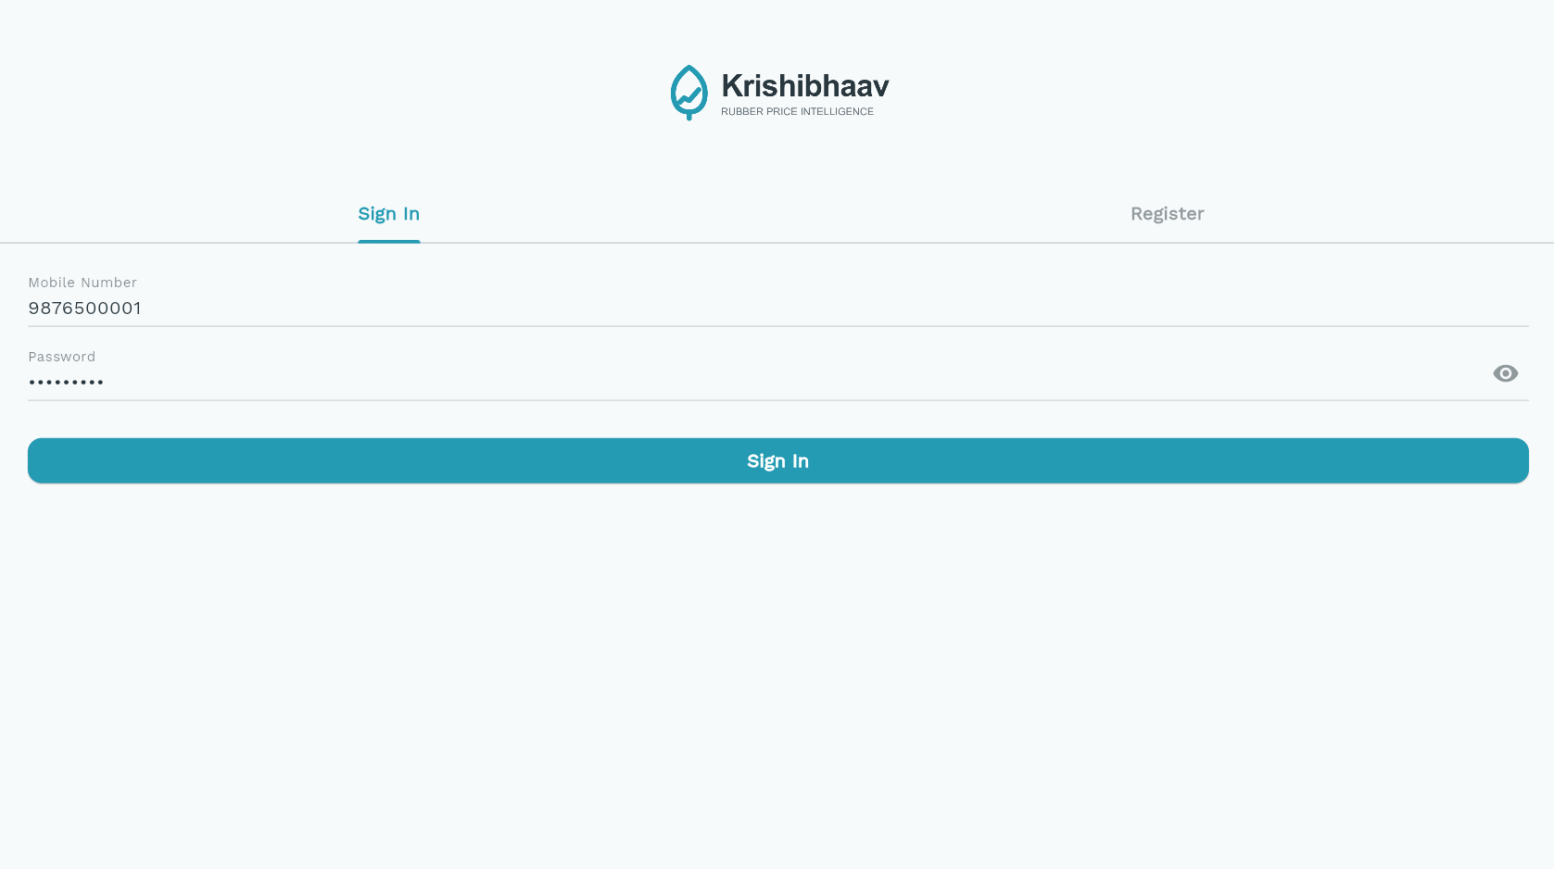
User Register Panel:
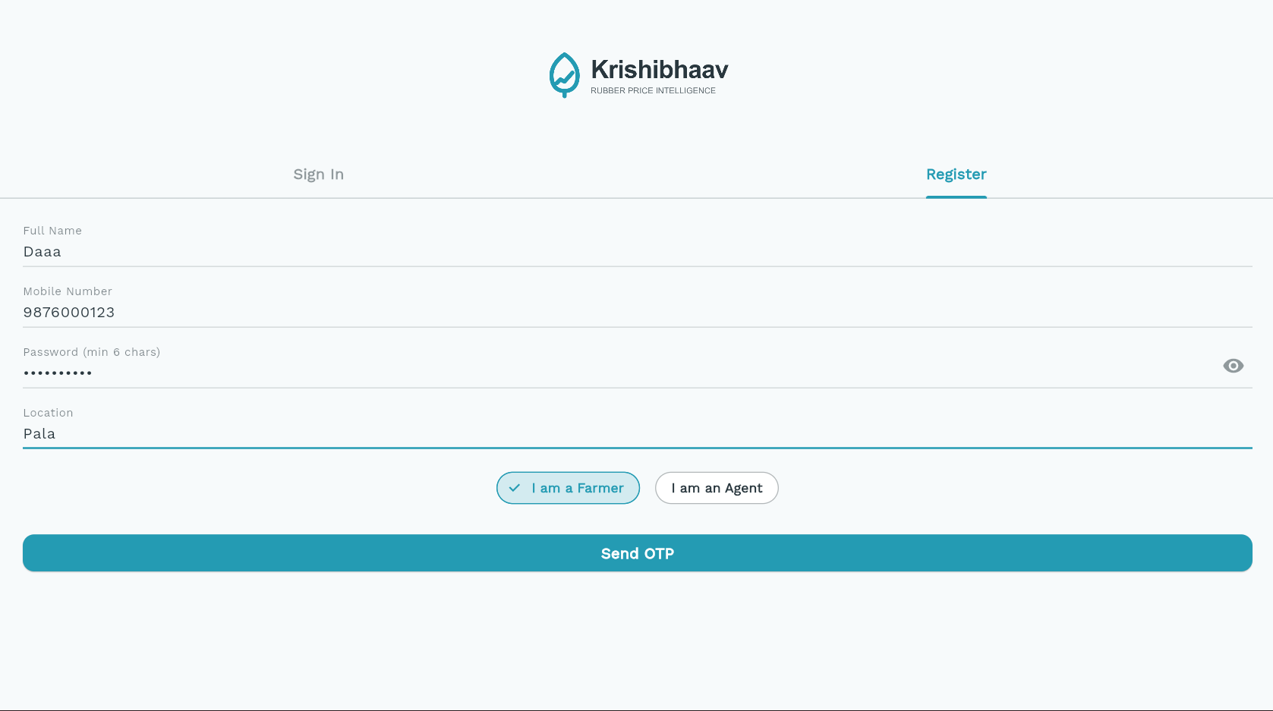

Agent Link
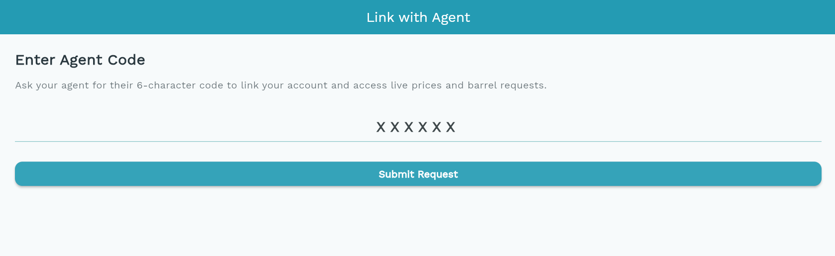
Dashboard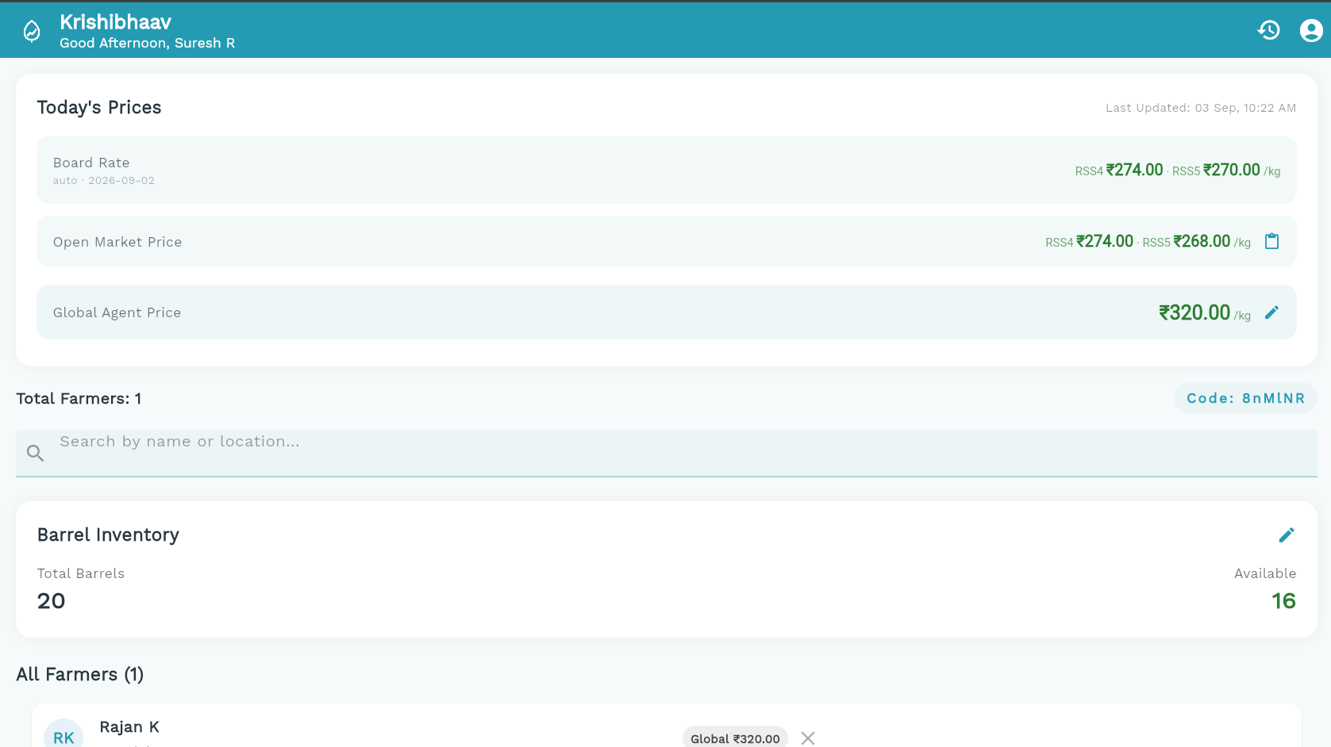

Farmer Profile Editing
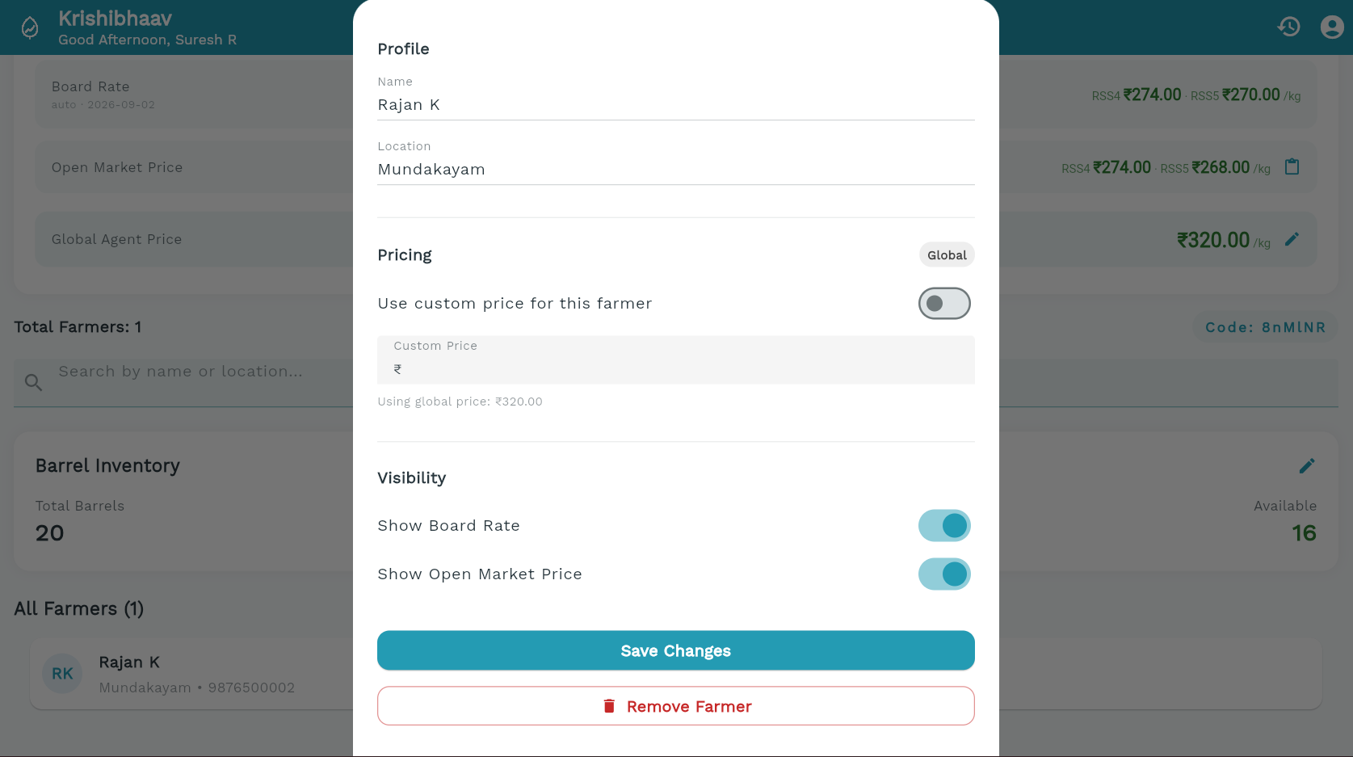
Agent Profile
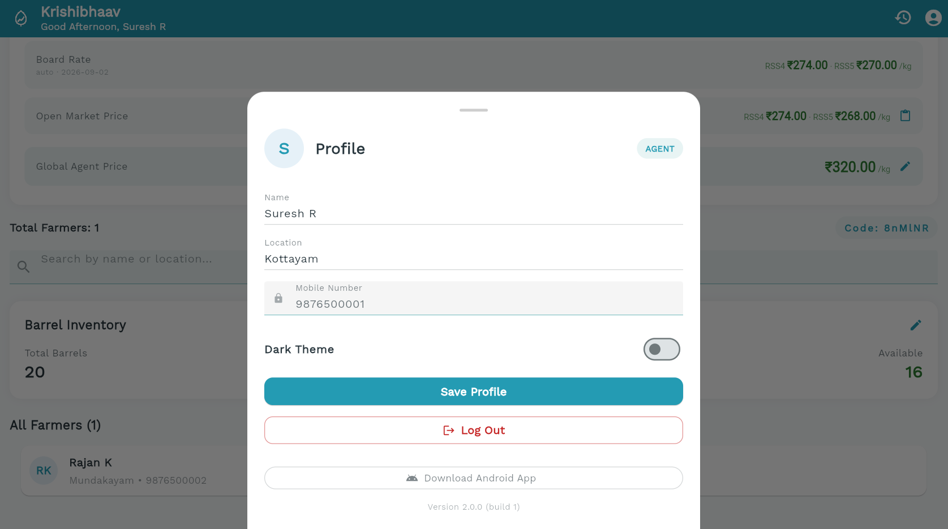

WhatsApp Price Parser
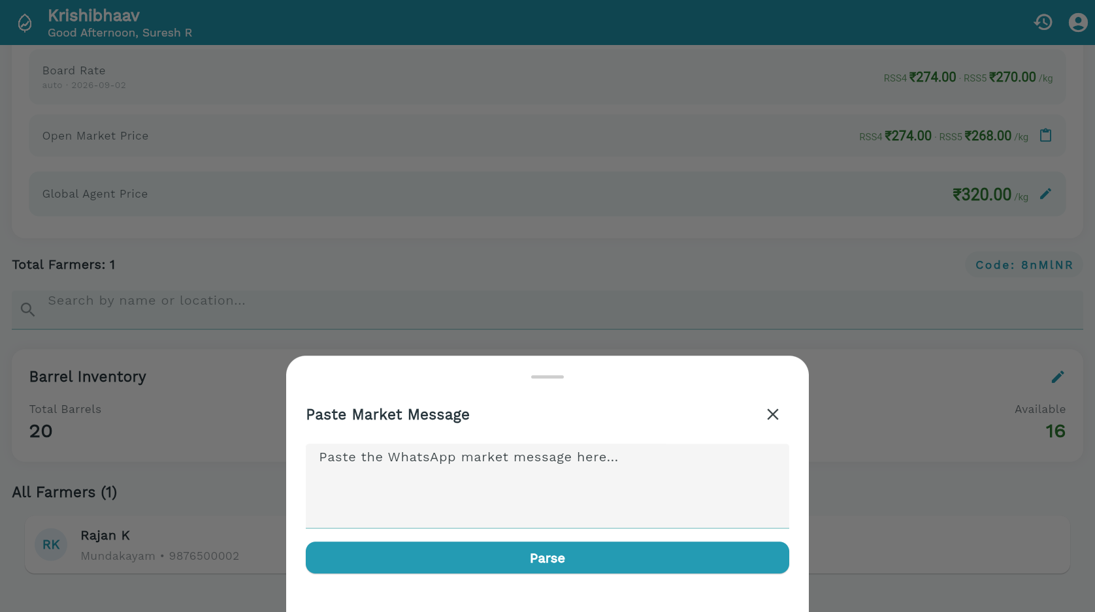
Agent Price Updater
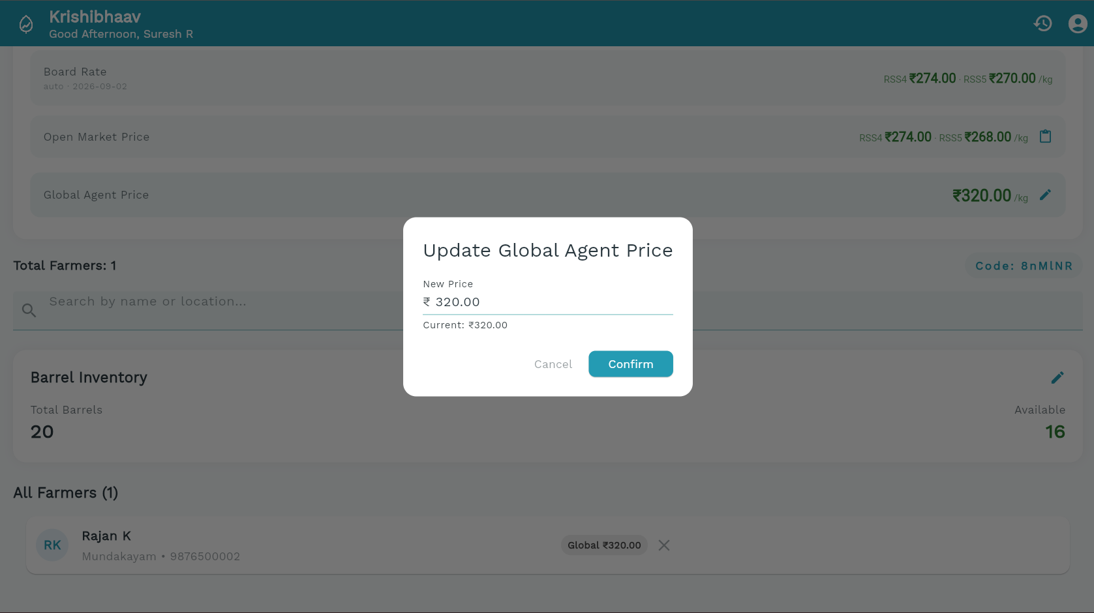

Barrel Updating
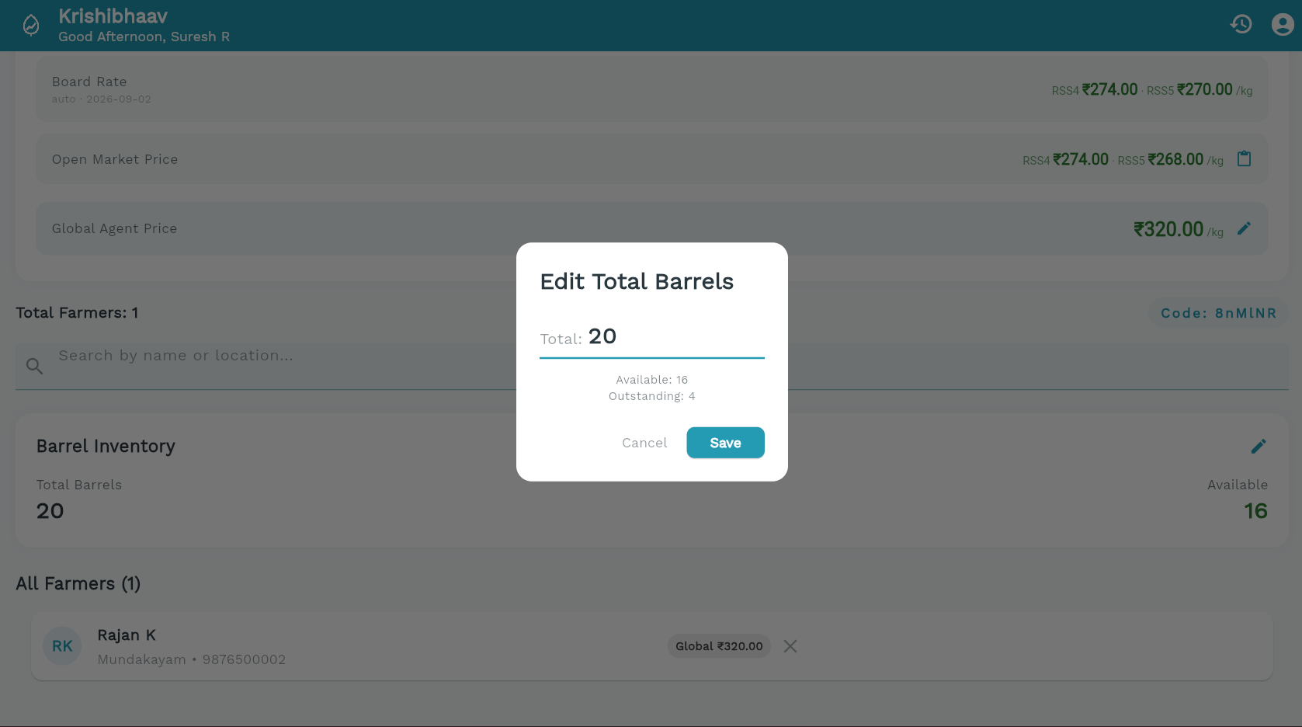

Booking History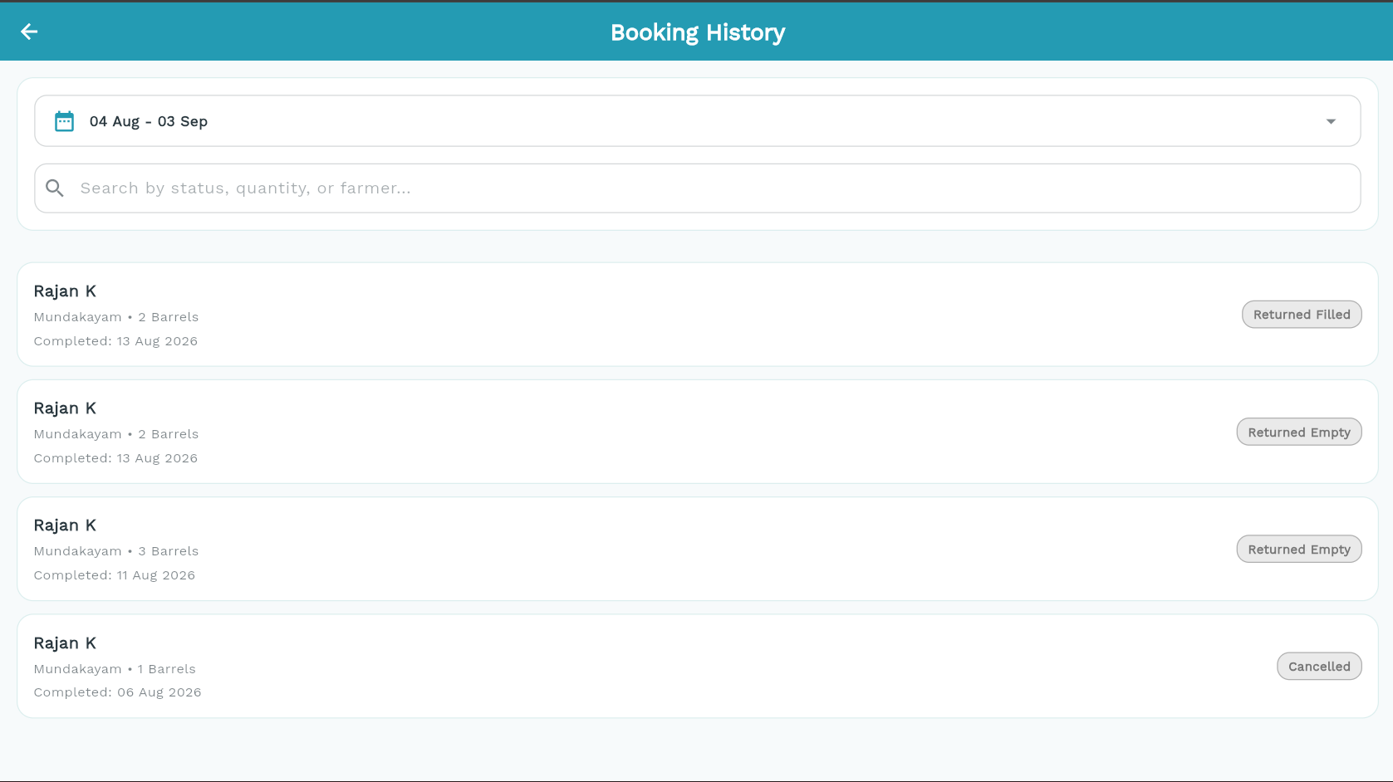

Farmer Dashboard
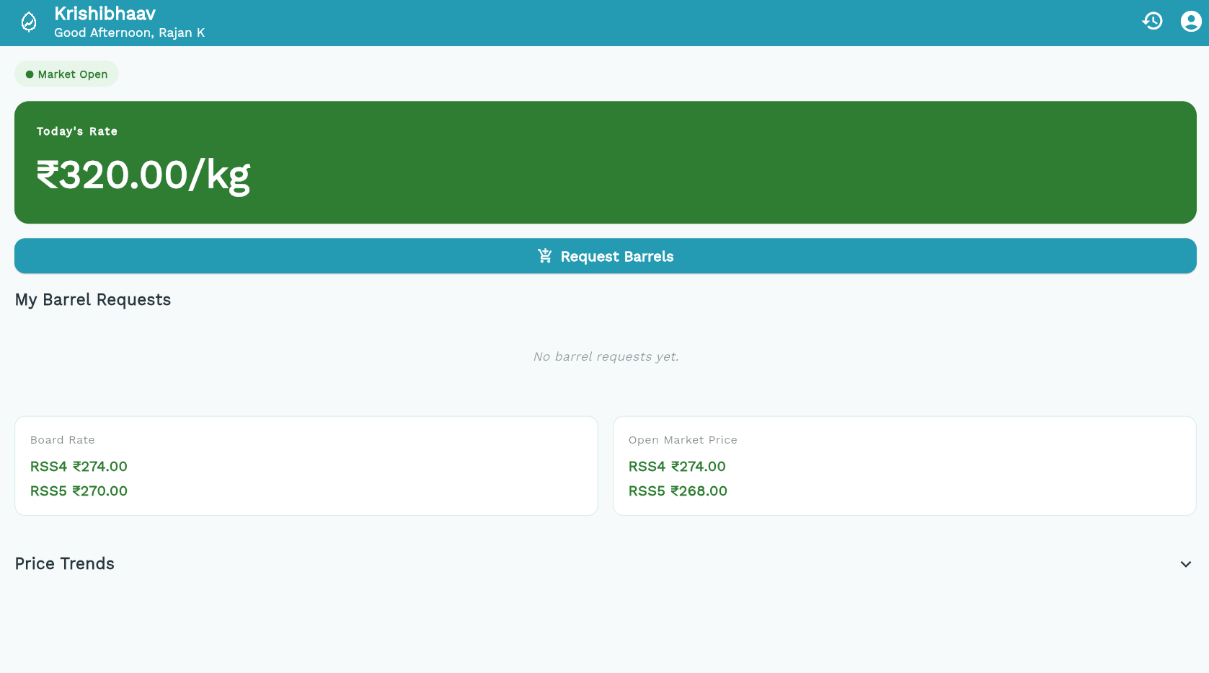

Farmer Profile
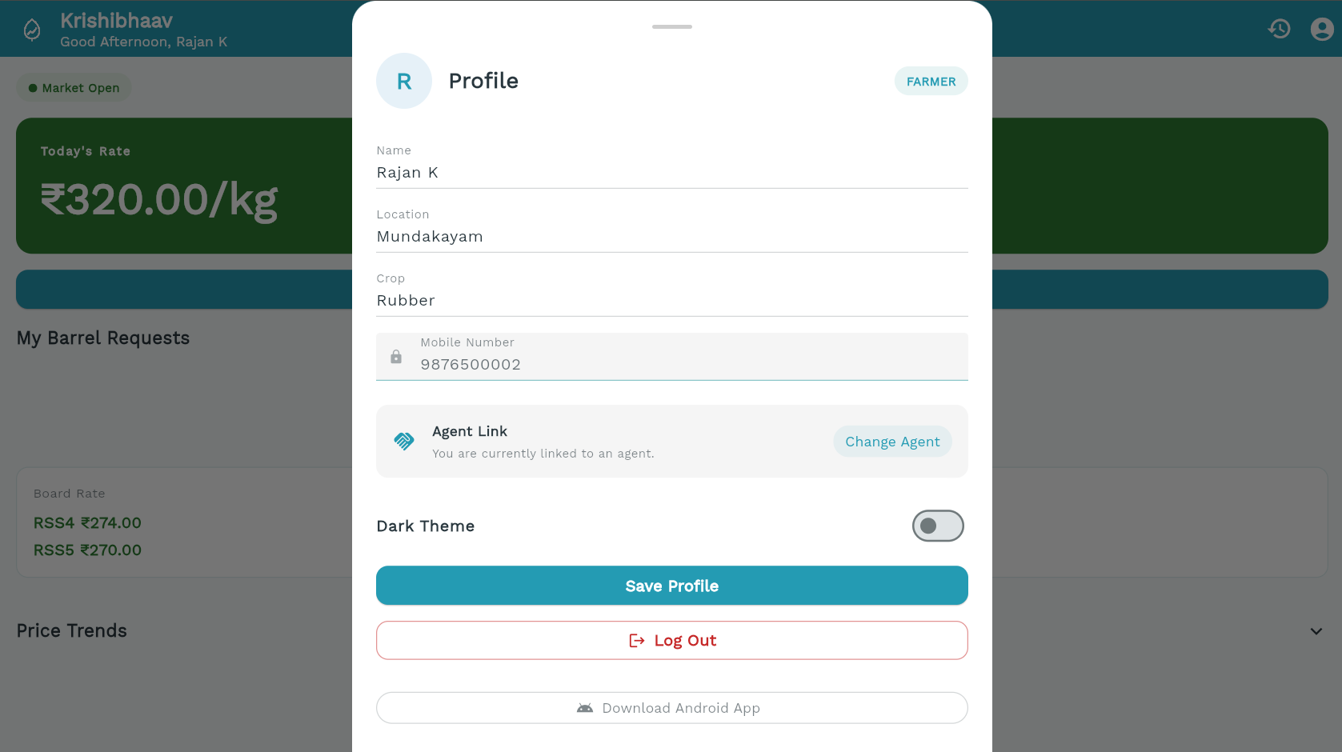

Farmer Barrel Request
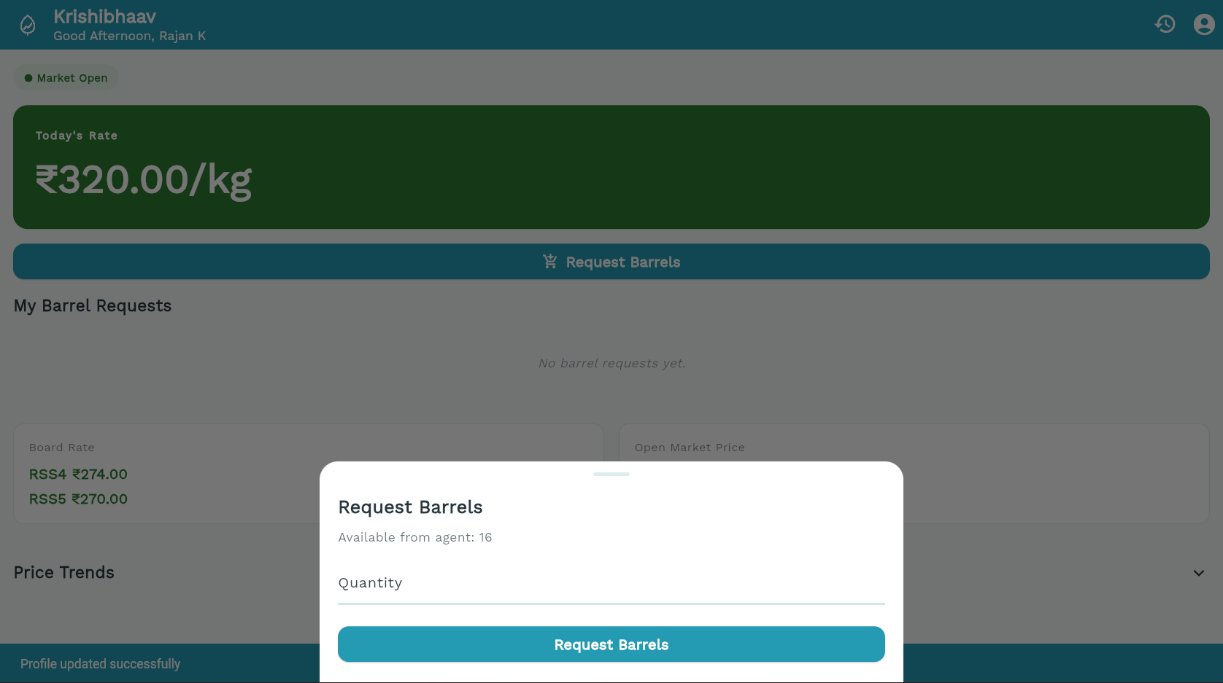

Farmer Price Trend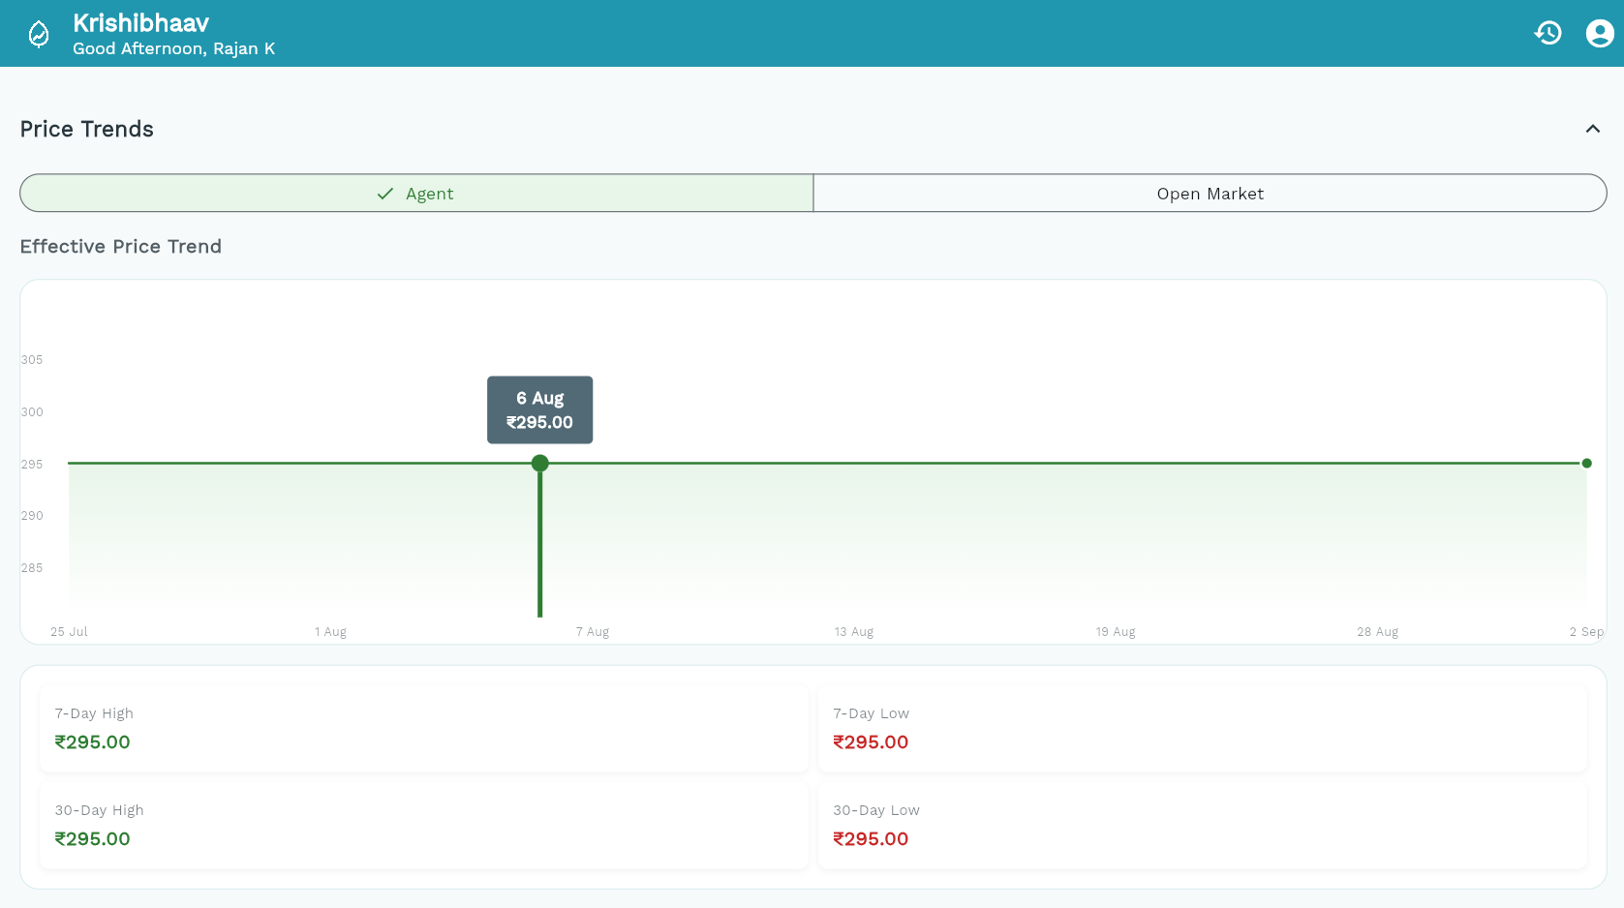

Non-Linked Farmer
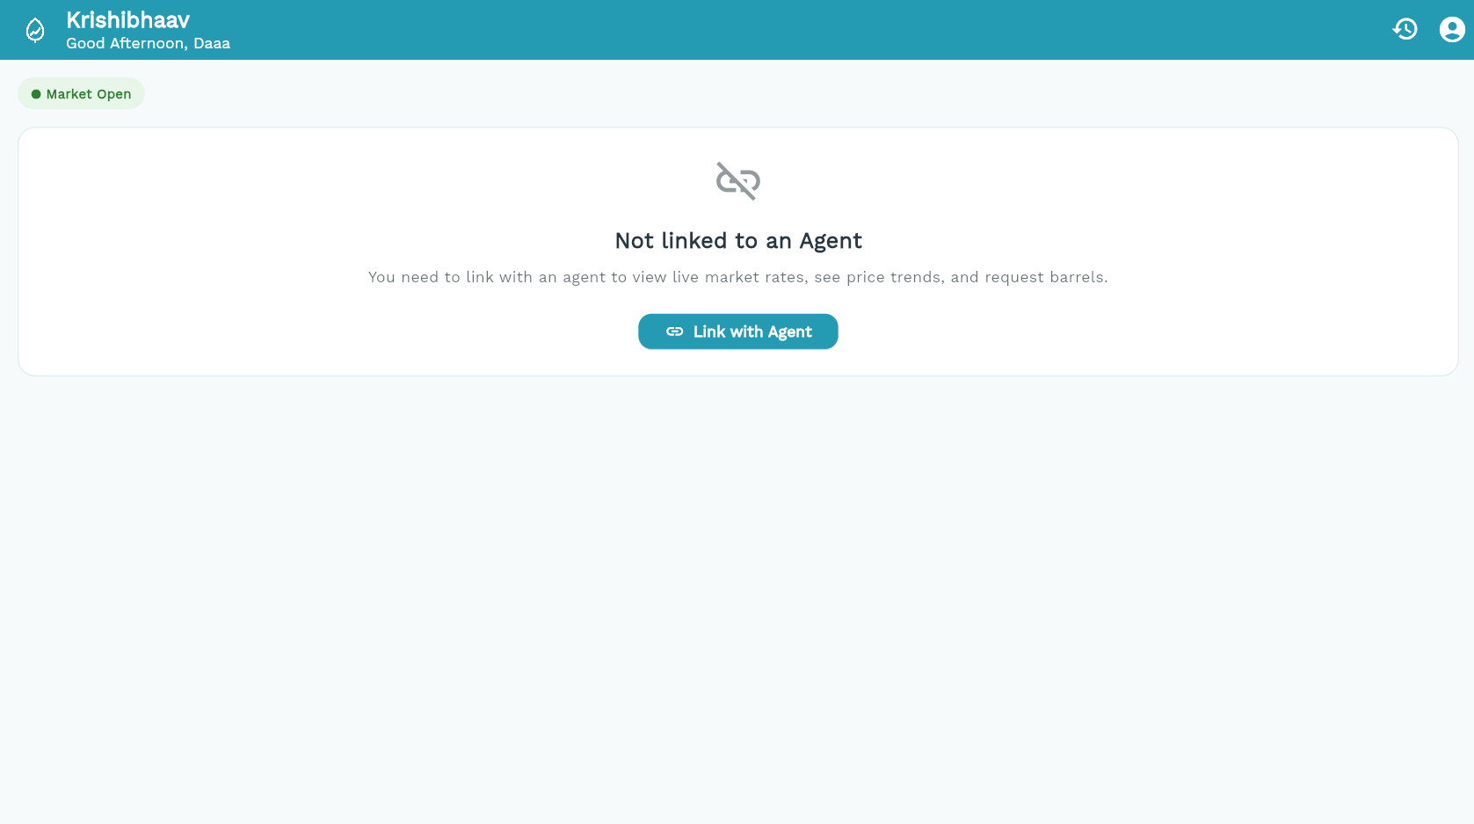
B. Sample Code
1. Barrel Logic:
class BarrelDecision {
final String? newStatus;
final int availableDelta;
const BarrelDecision(this.newStatus, this.availableDelta);
}

BarrelDecision decideApprove(String currentStatus, int quantity, int available) {
if (currentStatus != 'requested') {
return const BarrelDecision(null, 0);
}
if (available < quantity) {
throw ArgumentError('overbooking');
}
return BarrelDecision('approved', -quantity);
}

BarrelDecision decideDispatch(String currentStatus) {
if (currentStatus == 'approved') {
return const BarrelDecision('dispatched', 0);
}
return const BarrelDecision(null, 0);
}
BarrelDecision decideReturn(String currentStatus, int quantity) {
if (currentStatus == 'dispatched') {
return BarrelDecision('returned', quantity);
}
return const BarrelDecision(null, 0);
}

BarrelDecision decideReturnEmpty(String currentStatus, int quantity) {
if (currentStatus == 'dispatched') {
return BarrelDecision('returned_empty', quantity);
}
return const BarrelDecision(null, 0);
}

BarrelDecision decideReturnFilled(String currentStatus) {
if (currentStatus == 'dispatched') {
return const BarrelDecision('returned_filled', 0);
}
return const BarrelDecision(null, 0);
}

BarrelDecision decideCancel(String currentStatus, int quantity) {
if (currentStatus == 'requested') {
return const BarrelDecision('cancelled', 0);
}
if (currentStatus == 'approved') {
return BarrelDecision('cancelled', quantity);
}
return const BarrelDecision(null, 0);
}
2. Message Parser:
class MarketMessageResult {
final double? openMarketRss4;
final double? openMarketRss5;
final String? error;

MarketMessageResult({this.openMarketRss4, this.openMarketRss5, this.error});
}

class MarketMessageParser {
static MarketMessageResult parseMarketMessage(String raw) {
if (raw.trim().isEmpty) {
return MarketMessageResult(error: 'Message is empty.');
}

// Match PARTY GODOWN followed by a number
final rss4RegEx = RegExp(r'PARTY\s+GODOWN\s+(\d+(?:\.\d+)?)', caseSensitive: false);
// Match RSS5(PSNG) followed by a number (tolerant of spaces around parens)
final rss5RegEx = RegExp(r'RSS5\s*\(\s*PSNG\s*\)\s+(\d+(?:\.\d+)?)', caseSensitive: false);

double? rss4;
double? rss5;

final match4 = rss4RegEx.firstMatch(raw);
if (match4 != null && match4.groupCount >= 1) {
final parsed = double.tryParse(match4.group(1)!);
if (parsed != null && parsed.isFinite && parsed >= 0) {
rss4 = parsed;
}
}

final match5 = rss5RegEx.firstMatch(raw);
if (match5 != null && match5.groupCount >= 1) {
final parsed = double.tryParse(match5.group(1)!);
if (parsed != null && parsed.isFinite && parsed >= 0) {
rss5 = parsed;
}
}

if (rss4 == null && rss5 == null) {
return MarketMessageResult(error: 'Could not find market prices in this message');
}

return MarketMessageResult(
openMarketRss4: rss4,
openMarketRss5: rss5,
);
}
}

C. Hardware and Software Requirements
Development Environment

Hardware
Processor: AMD Ryzen AI 7 350 with Radeon 860M Graphics, 2.00 GHz
RAM: 24 GB (23.3 GB usable)
Storage: 954 GB (265 GB used)
Graphics: AMD Radeon 860M Graphics
System type: 64-bit operating system, x64-based processor

Software
Operating system: Windows 11 Home Single Language, version 26H2 (OS build 26300.9711)
Editor: Visual Studio Code with the Dart and Flutter extensions
Framework: Flutter
Language: Dart
Back end: Firebase (Authentication, Cloud Firestore, Hosting)
Scraper: Python run on GitHub Actions
Version control: Git and GitHub

Client Requirements
An Android phone, or any modern web browser, with an internet connection.

D. Bibliography
- Flutter documentation, docs.flutter.dev
- Dart documentation, dart.dev
- Firebase documentation, firebase.google.com/docs
- pub.dev packages: provider, rxdart, go_router, fl_chart, shared_preferences, pub.dev
- GitHub Actions documentation, docs.github.com/actions
- The Rubber Board, Government of India, rubberboard.gov.in (Indian Rubber Statistics)

